MR KAMUNDELU
CHEMISTRY LESSON PLAN
GRADE | TOPIC | SUB TOPIC | DURRATION | DATE
10 | bonding | covalent | ___ min | ___/___/___

RATIONALE : Covalent bond Covalent bonding is a form of chemical bonding where pairs of electrons are shared between atoms. Group/ pair work and demonstration will be used to execute the first lesson of three in the series.
SPECIFIC OUTCOMES, LSBAT: - Describe the formation of covalent bonds
- Classifying covalent compounds compounds.
- Describe the electronic arrangement in simple
multiple covalent molecules Such as double bonds
in O2,C2H4andCO2, Triple bond in N2and C2H2
PRE-REQUISITE SKILLS : learners have knowledge on bonding of atom.
TEACHING/ LEARNING AIDS : chemistry key point’s pupils book 10.
REFFERENCES : chemistry 10, chemistry made clear. Certificate
Chemistry 4th edition.
LESSON PROGRESSION
STAGE | T/L ACTIVITY | LEARNING POINTS
INTRO-  DUCTION  ____min | Revise on how atoms become ions.
D  E  V  E  L  O  P  M  E  N  T  ____min | ACTIVITY 1  What is covalent bonding  Activity 2  it is only the valence electrons that are involved in bonding, and so when diagrams are drawn to show what is happening during bonding, it is only these electrons that are shown. Circles and crosses represent electrons in diﬀerent atoms.  Formation of hydrogen chloride  Step 1: Determine the electron conﬁguration of each of the bonding atoms. A chlorine atom has 17 electrons, and an electron conﬁguration of 2: 8: 8: 1. A hydrogen atom has only 1 electron, and an electron conﬁguration of 1.  Step 2: Determine the number of valence electrons for each atom, and how many of the electrons are paired or unpaired. Chlorine has 7 valence electrons. One of these electrons is unpaired. Hydrogen has 1 valence electron and it is unpaired.  Step3: Look to see how the electrons can be shared between the atoms so that the outermost energy levels of both atoms are full | Covalent bond Covalent bonding is a form of chemical bonding where pairs of electrons are shared between atoms.  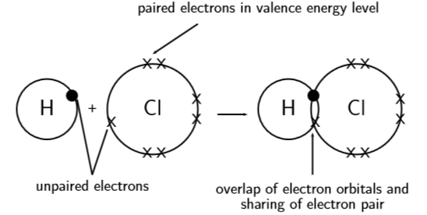  CHARACTERISTICS OF CONVALENT BONDING  • Covalent bonding occurs between the atoms of non-metals and involves a sharing of electrons so that the orbitals of the outermost energy levels in the atoms are ﬁlled.  • The valency of an atom is the number of bonds that it can form with other atoms.  • A double or triple bond occurs if there are two or three electron pairs that are shared between the same two atoms.
C  O  N  L  U  S  I  O  N  ____min | Exercise  formation of ammonia (NH3)

EVALUATION: ………………………………………………………………………………………………………………………………………………………………………………………………………………………………………………………………………………………………………

